VF Audit - Areas of Opportunity:

Optimizing API Calls for Latency Reduction

Given our fast-track experiences brought in high latency due to the additional API calls, we need to carefully select the best locations to call them. Our goal is to balance early-flow eligibility checks with latency breakage to drive the most lift. Our areas of opportunity here are as follows:

- Splitting up API calls in between scripts to reduce latency for any single step.
- Moving the heaviest API calls to the steps with the lowest current latency.
- Removing unnecessary blocks, whether API calls or not, to speed up the flow.

Organization & Visuals
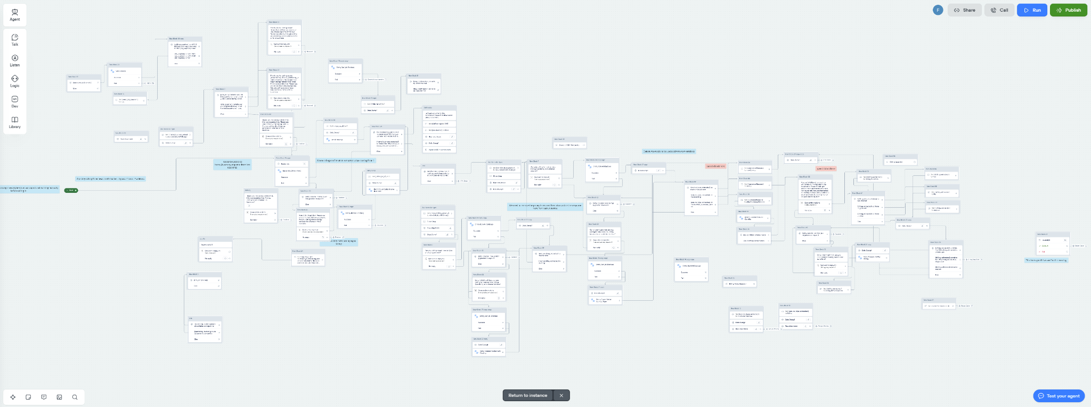
Current Initial Question Flow

Some steps in our flow have become unreadable without spending time following each block closely. The above screenshot of the initial question flow is an example. There is a somewhat clear flow of left to right, but it’s hard to pinpoint important moments, like where callers are split into different experiences or when they’re passed on to the next step within the flow. This means that stakeholders lose visibility into the flow, and although granular knowledge isn’t necessary for those not interacting/updating with the flow directly, questions have come up about scripting and general logic. There are several changes we want to make to organize the flows and make this information more accessible:

- Increase spacing and restructure to follow left -> right, up -> down. This makes the flow naturally easier to follow.
- Add comments above every block (or 2-3 blocks) to help people identify where certain actions are taking place within the flow. In addition, larger comments should be used to identify entire sections. Similarly, each block should be named accurately. I would estimate ~30-40% of our blocks are actually given a name.
- Remove or organize unused blocks. Currently, almost all of our flows have blocks that were previously used, but now sit on the outskirts disconnected from all other blocks. If they are related to changes that may be reverted, they will remain on in the flow, but separated into a section solely for unused blocks. Otherwise, they will be removed.

Here’s an example of a good flow, that tracks well with natural reading patterns, is annotated well, and has taken care of unused blocks.

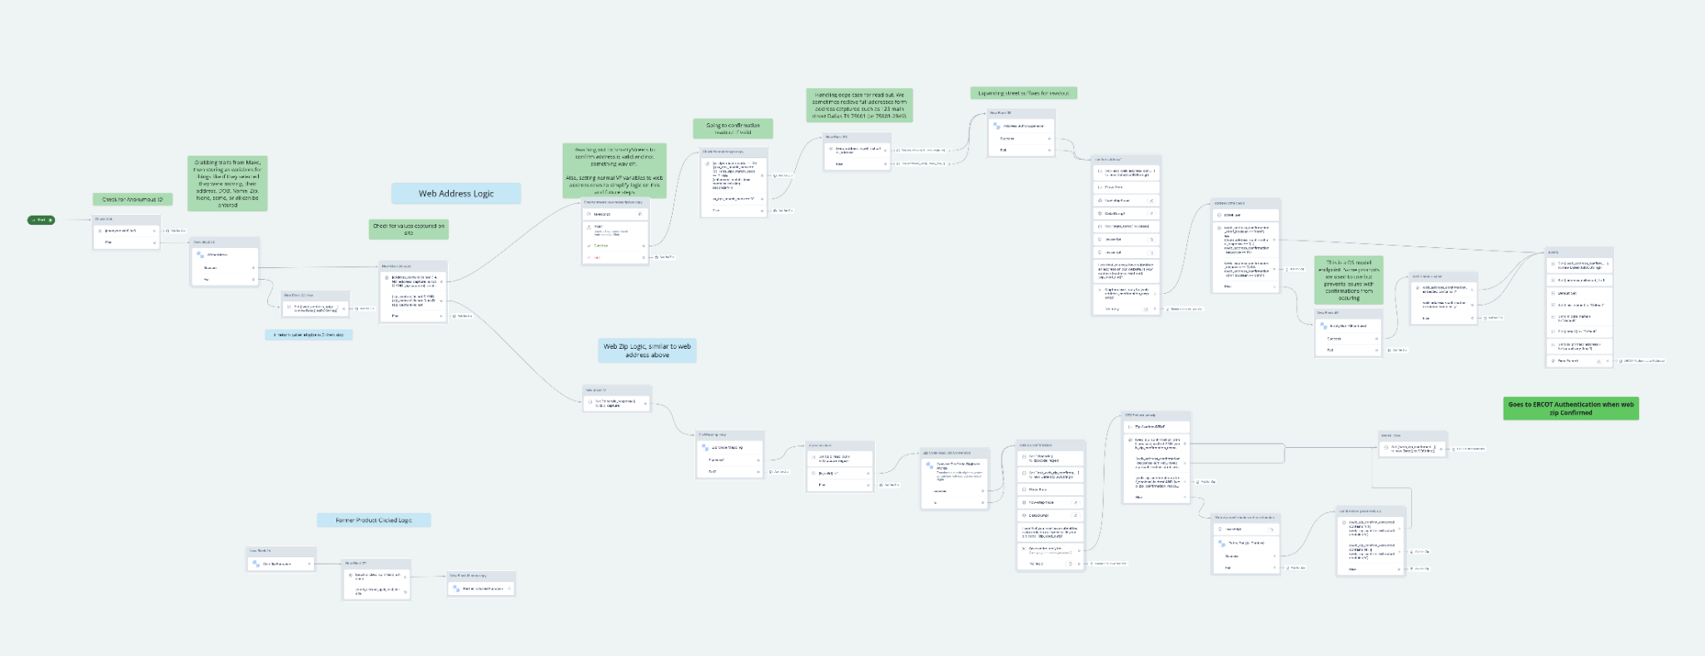
Current Web Address/Zip Flow

Still, this flow could be updated with more comments, specifically in the Web Zip Logic on the bottom split. Improved clarity would help us diagnose bugs and make flow changes more quickly.

Increasing Modularity

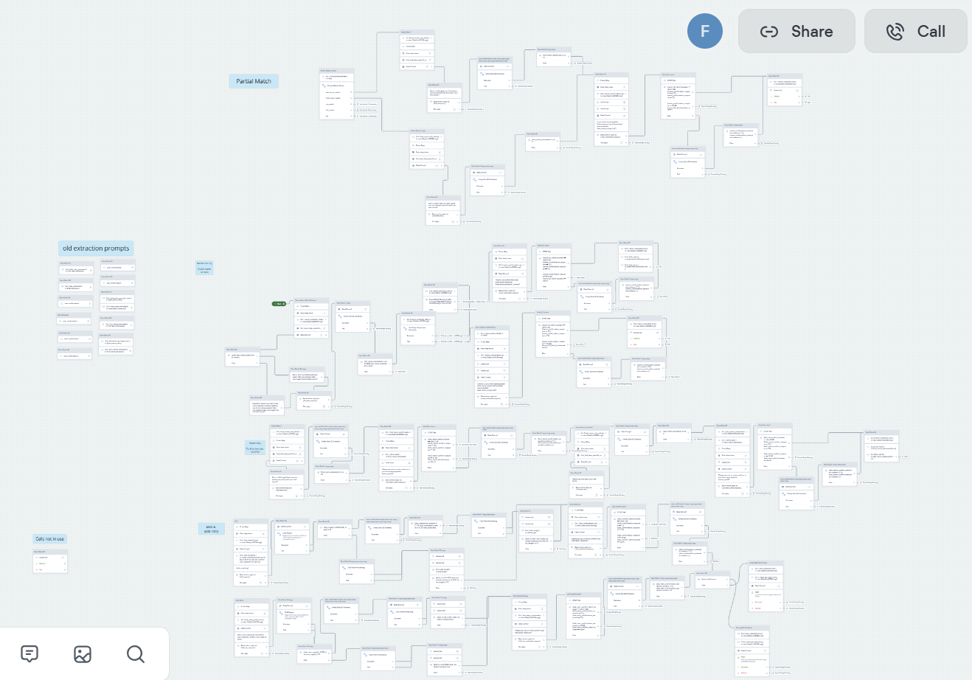
Current Name/DoB Flow

Components in our flow not only have a style complexity, but also content bloat. Our Name Collection step is shown above and contains first attempt name collection, partial match handling, the name retry flow, first DoB collection attempt, and DoB retry flow. We should separate these steps into smaller, more focused components to improve maintainability and testing.

